Deploying a Highly Available Web Application and Bastion Host in AWS

* Created a VPC with IP- 10.0.0.0/16

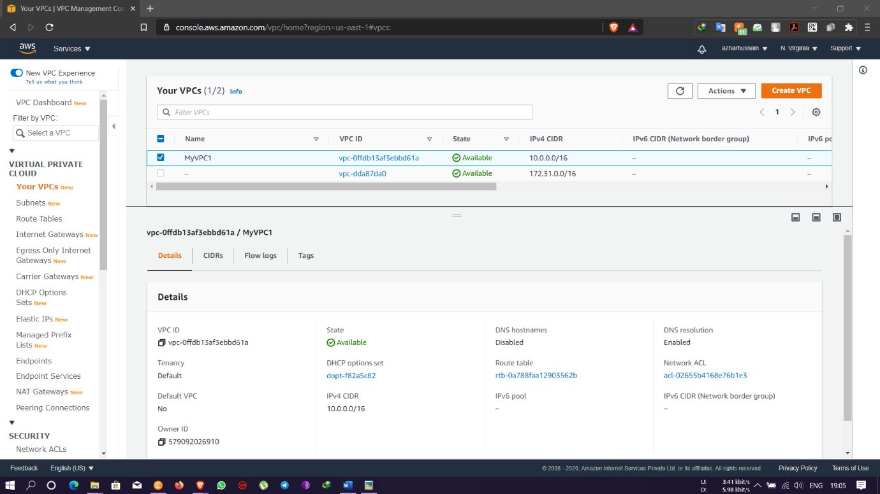

* Created a public subnet with IP- 10.0.0.0/24 within the VPC & enabled auto-assigned IPv4 address

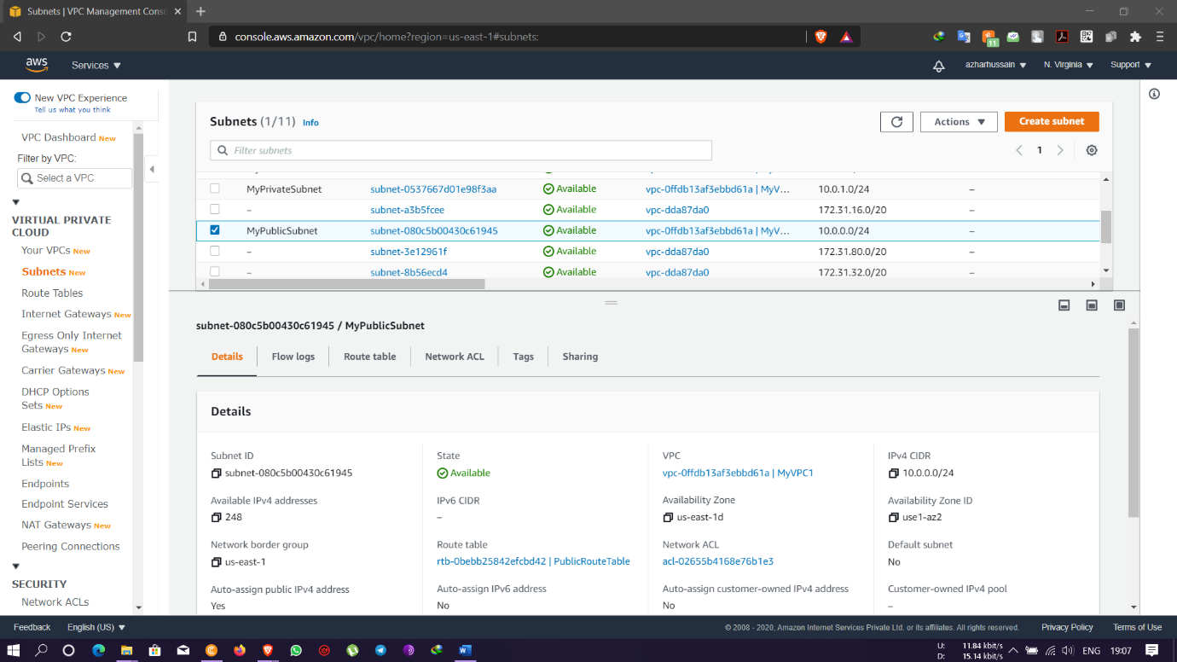

* Created a private subnet with IP- 10.0.1.0/24 within the VPC created

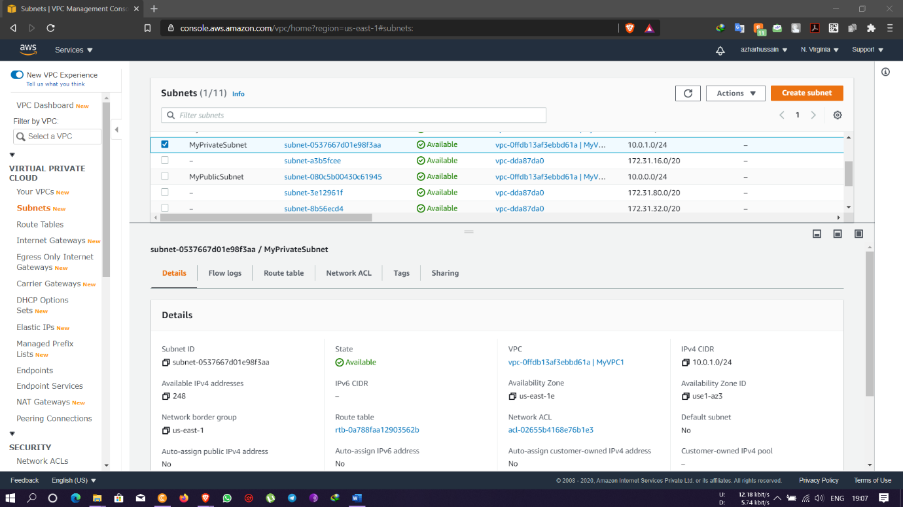

* Created an Internet gateway and attached to the VPC created

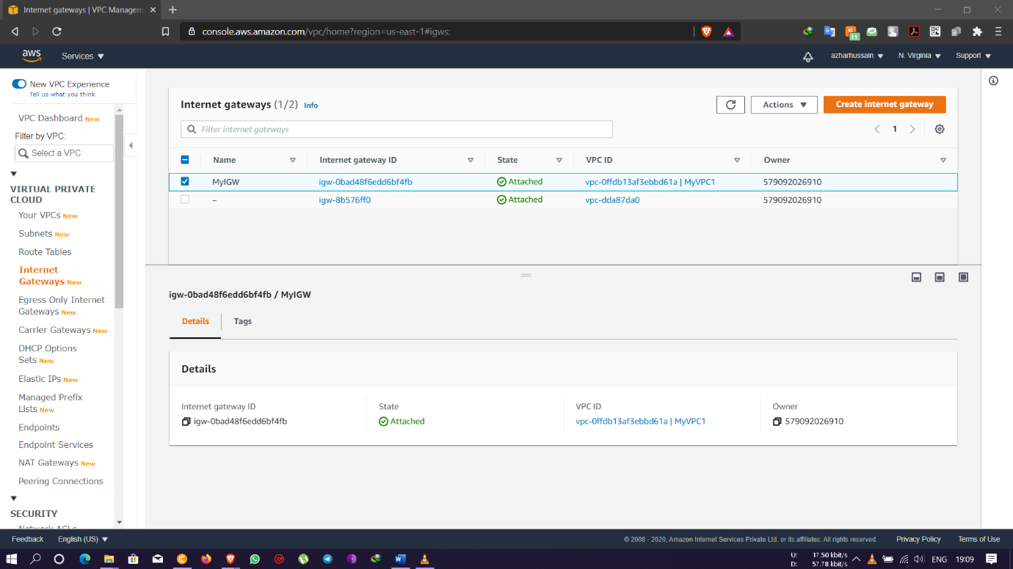

* Created a public route table not making it the main route table and added route with 0.0.0.0/0 and attached the IGW to the routes table

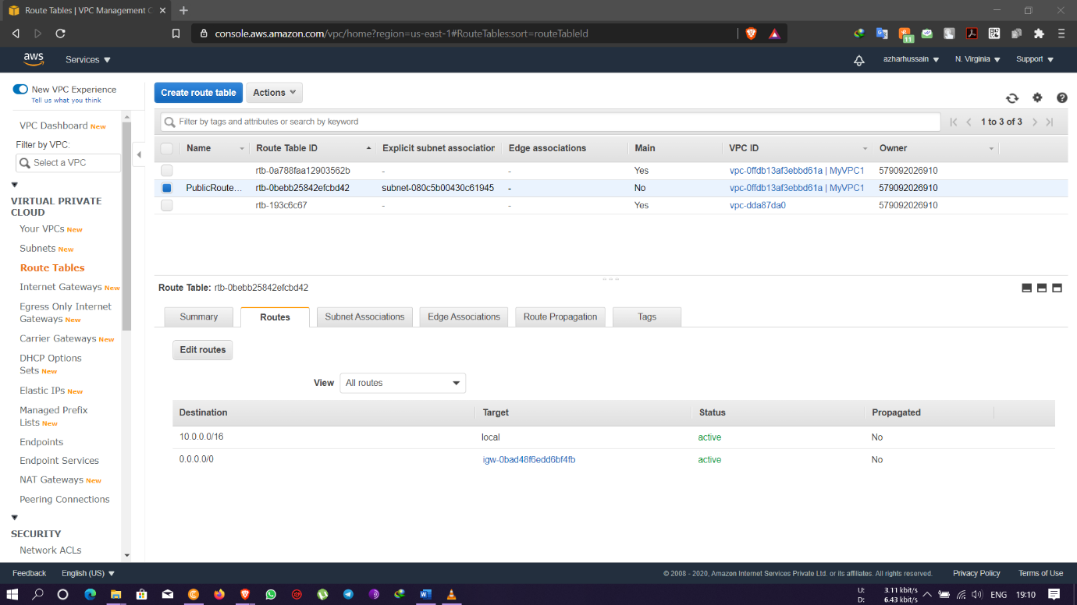

* Created a NAT gateway within the public subnet and allocated an Elastic IP

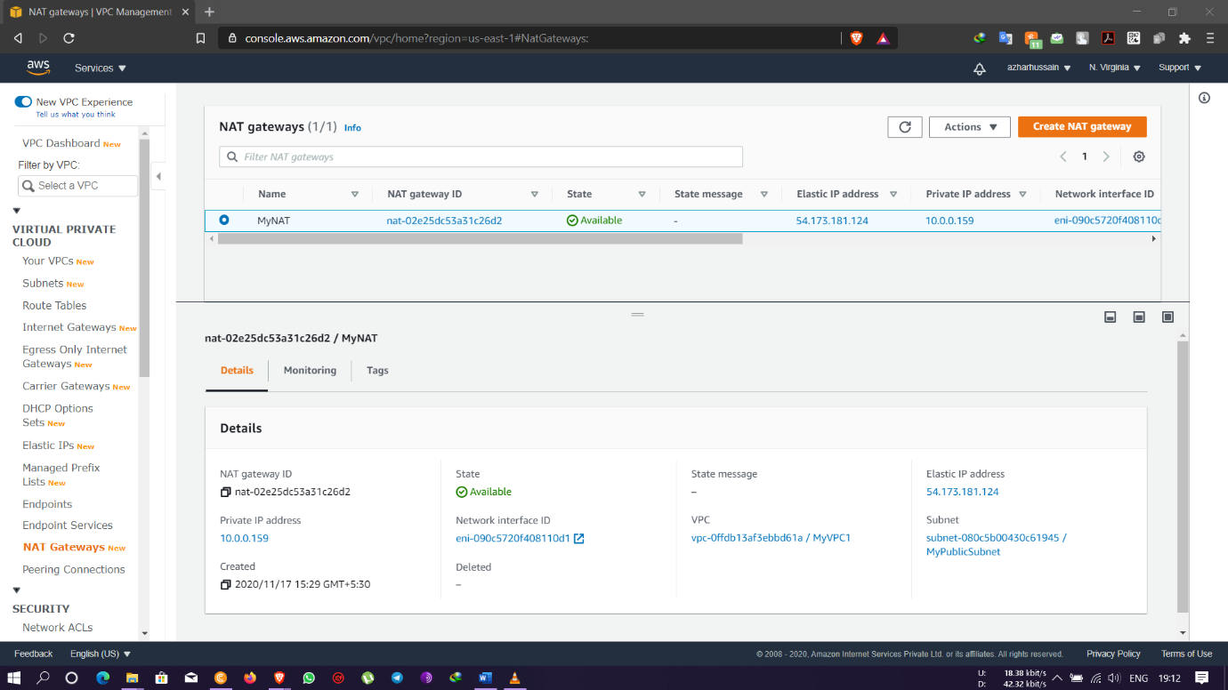

* In the main route table added route as 0.0.0.0/0 with target as NAT gateway which was created

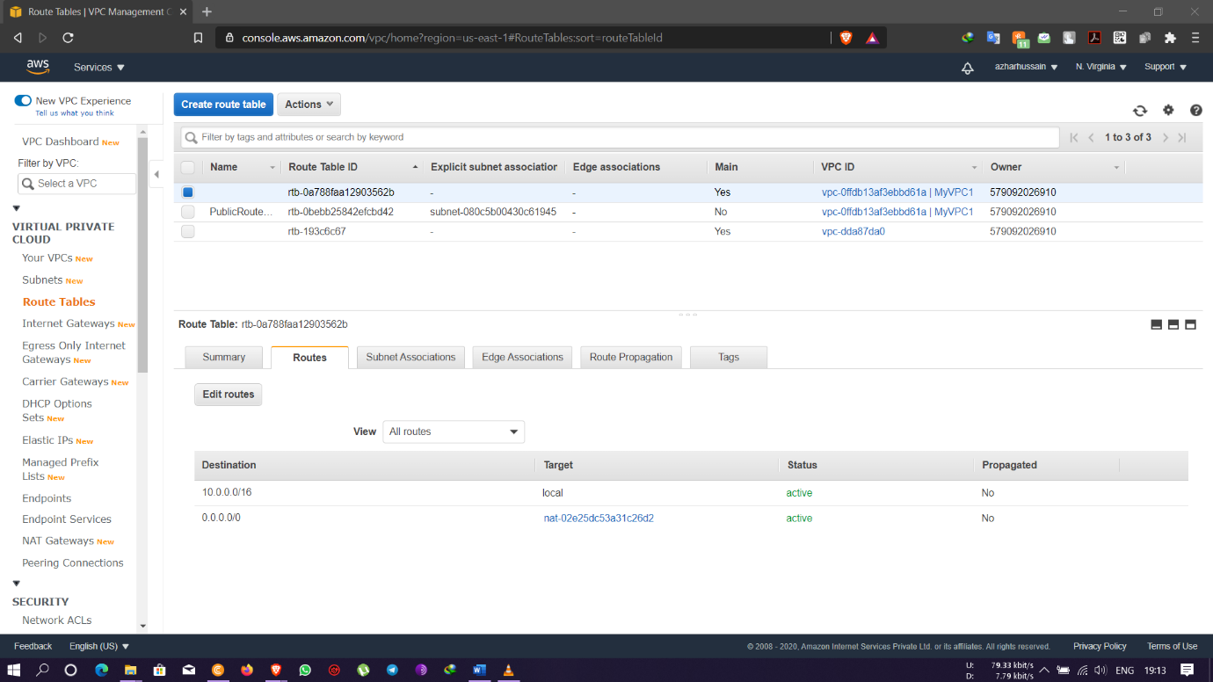

* created a Linux instance with the VPC created and public subnet and named as Bastion-Server which will act as a proxy server

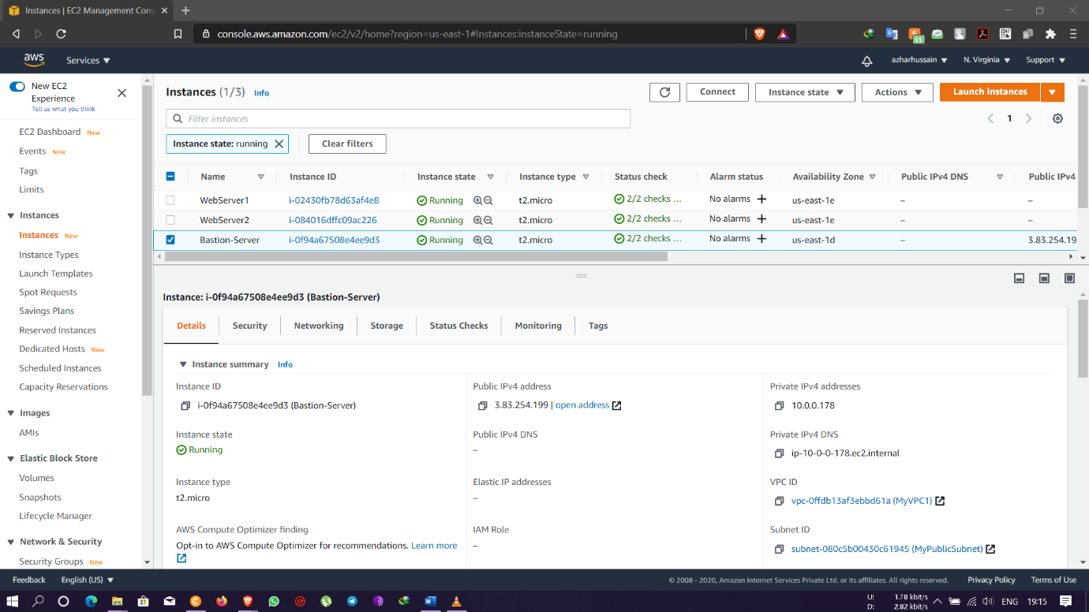

* Bastion-Server Security groups allowing inbound SSH connection at port 22 with TCP protocol with custom IP- 0.0.0.0/0

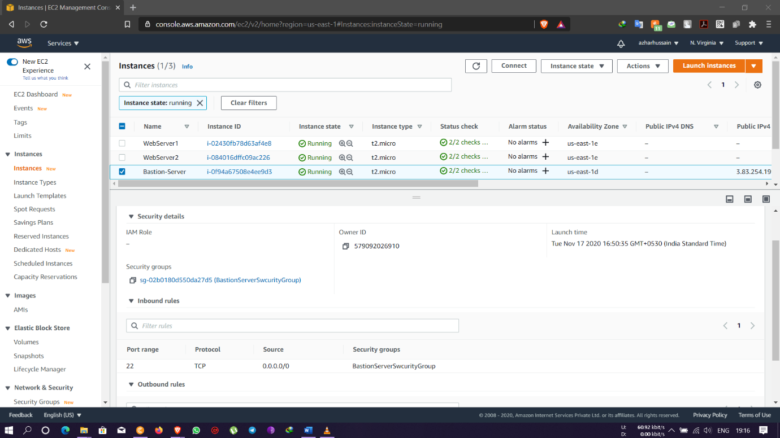

* Created a load balancer security group by allowing inbound rules of HTTP with protocol TCP and port 80 through the source custom IP- 0.0.0.0/0

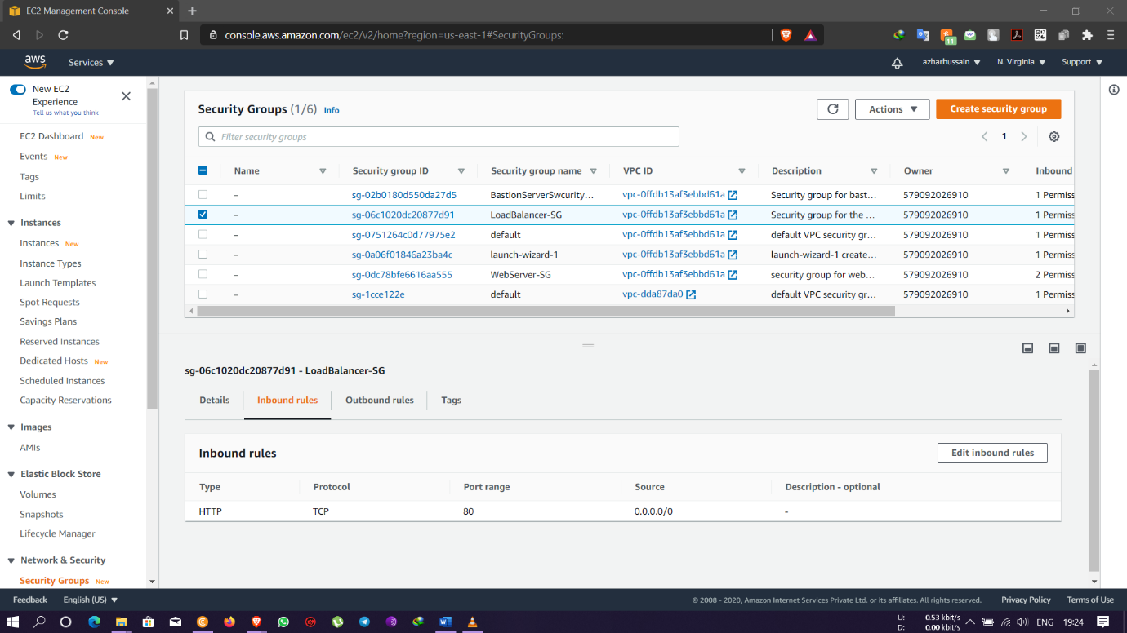

* Created a Linux instance withing the VPC created and private subnet and disabling the auto assigning IP and named as Webserver 1

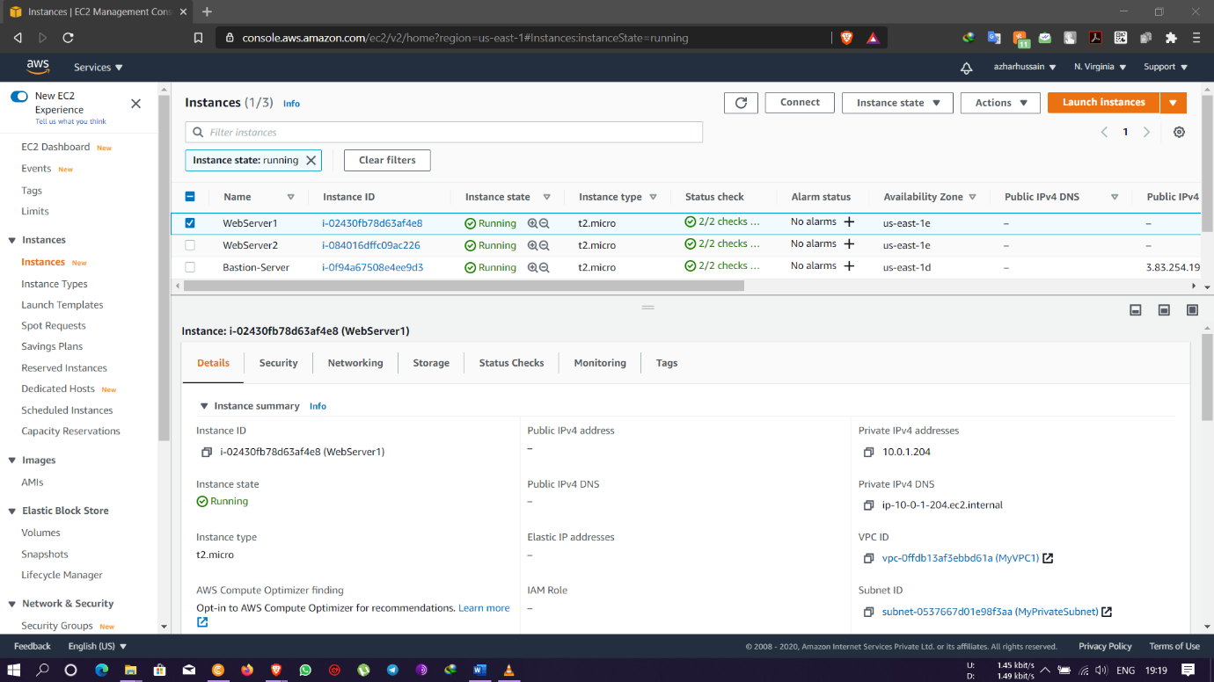

* Security groups created by allowing Port 80 & 22 for HTTP and SSH connections

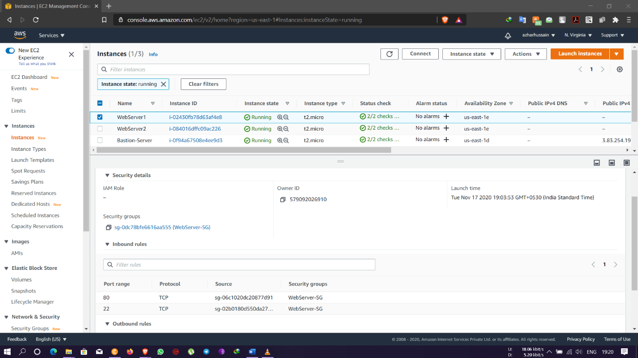

* Created a Linux instance withing the VPC created and private subnet and disabling the auto assigning IP and named as WebServer 2

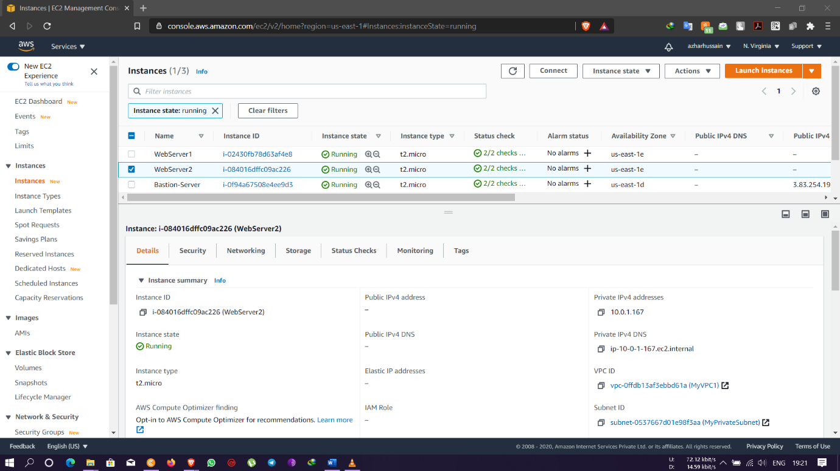

* Security groups created by allowing Port 80 & 22 for HTTP and SSH connections or by adding the existing security groups created for webserver 1

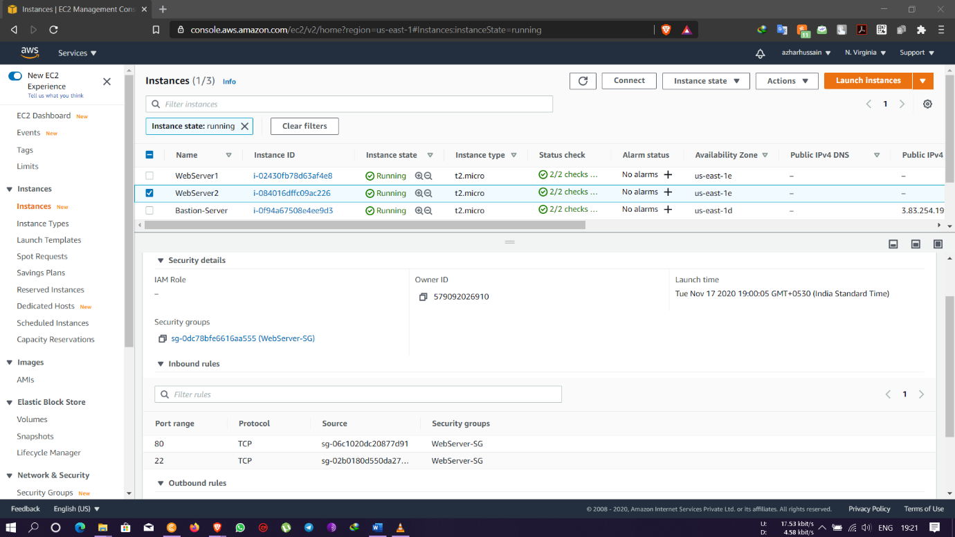

* Created a load balancer and added Webserver 1 & Webserver 2 as targets with the VPC created and the Availability Zones to the public and Private subnets

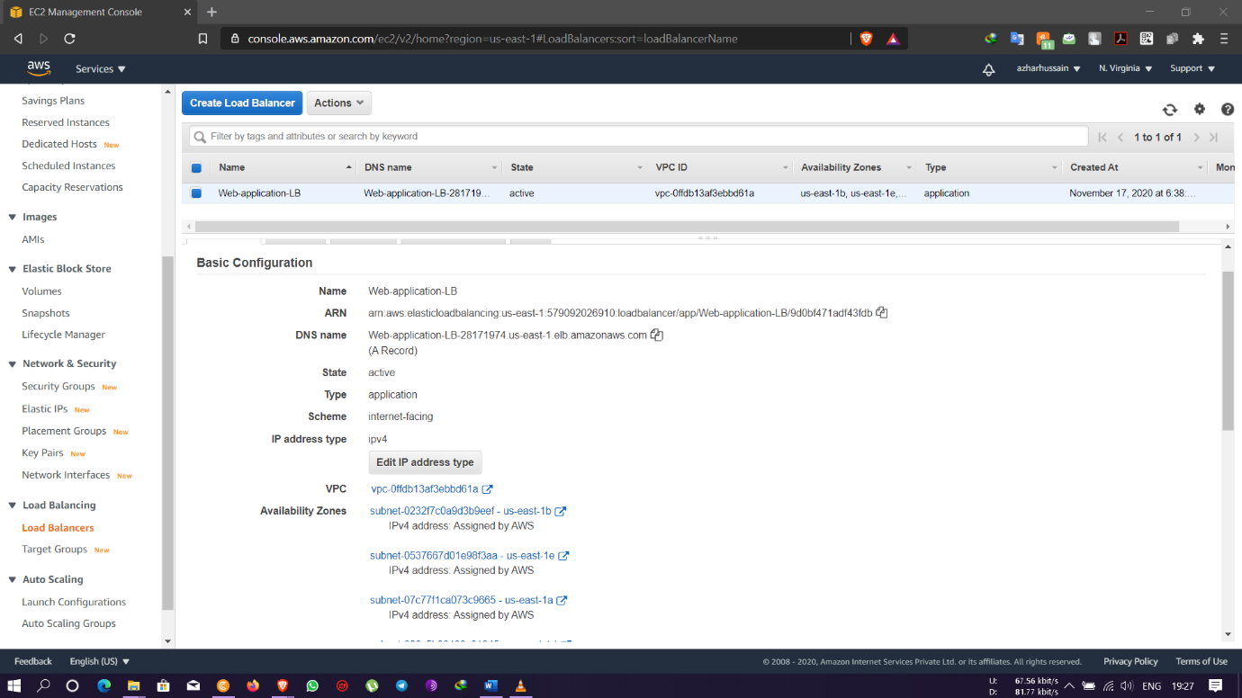

* Load balancer security groups attached to the load balancer

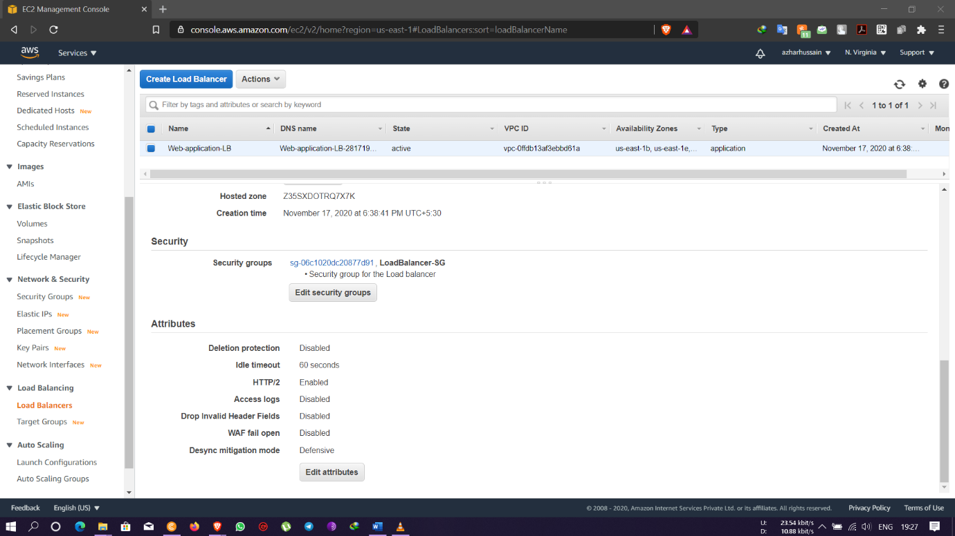

* [SSH into the Bastion server](https://play.whizlabs.com/site/task_support/ssh-into-ec-instance) using the Bastion PEM key: **Mykeypair.pem**

Navigate to the Bastion server and create a file named **web-serverkey.pem** with the vi editor using below command: **vi  web-serverkey.pem**

Then paste the key content and save it by pressing**esc** then **shift+colon followed** by **:wq**and then enter to save your private key.

Next then changed the **permission of the key file to 400** by using below command:

**chmod 400 web-serverkey.pem**

Now we log into the Web servers 1 & Web Server 2using the private key copied to the bastion server with the help of below commands:

On Web Server 1 **ssh -i web-serverkey.pem  ec2-user@10.0.1.204**       &

On Web Server 2 **ssh -i web-serverkey.pem  ec2-user@10.0.1.167**

next then we get super user access, installing apache server into the directory /var/www/html starting the apache service with an echo command with index.html for the load balancer DNS to upload the web pages using the commands:

sudo su

yum update -y

yum install httpd -y

systemctl start httpd

systemctl enable httpd

cd /var/www/html

echo “REQUEST HANDLING BY SERVER 1” > index.html &

echo “REQUEST HANDLING BY SERVER 2” > index.html

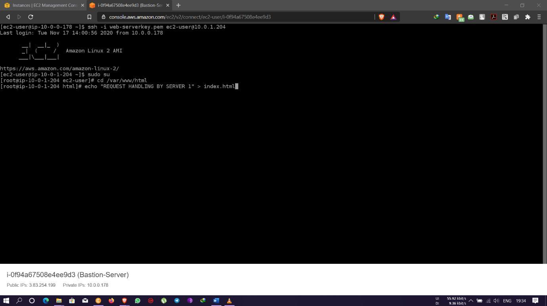

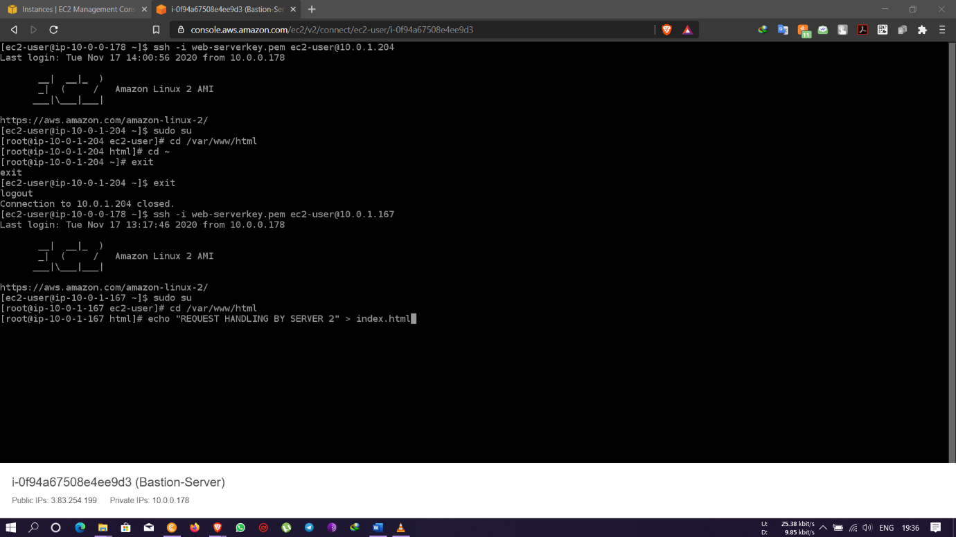

* In the target groups we go to where we had created the web application target group to check the health status to be in healthy state of both the web servers within HTTP port 80

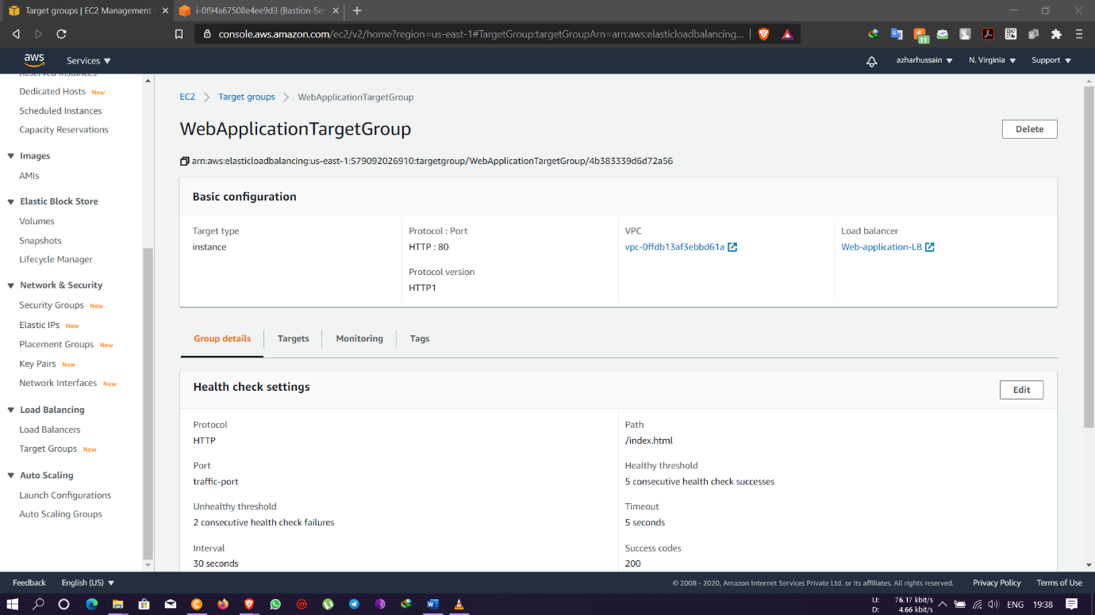

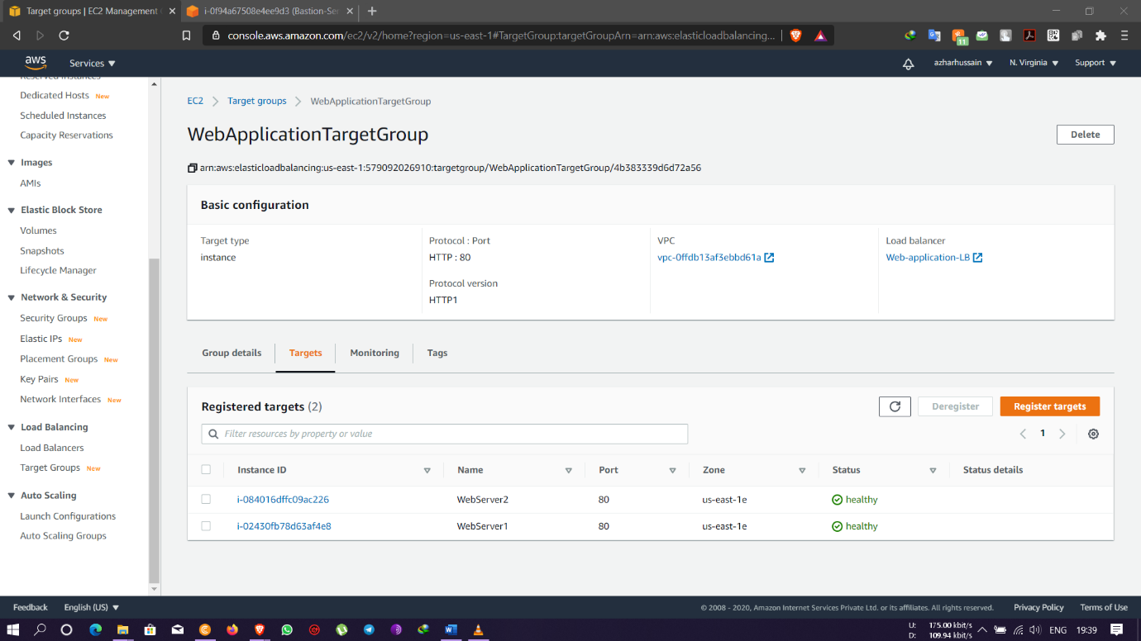

* Load balancer DNS output of web servers showing results of the echo commands stating both the web servers 1 & 2 are handling requests simultaneously





* When Web Server 1 was stopped it was found that the request was handled by web server 2

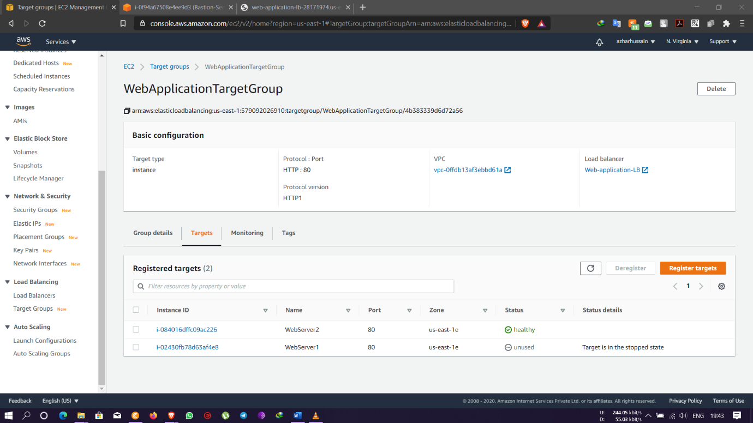



* When Web Server 1 was stopped it was found that the request was handled by web server 1

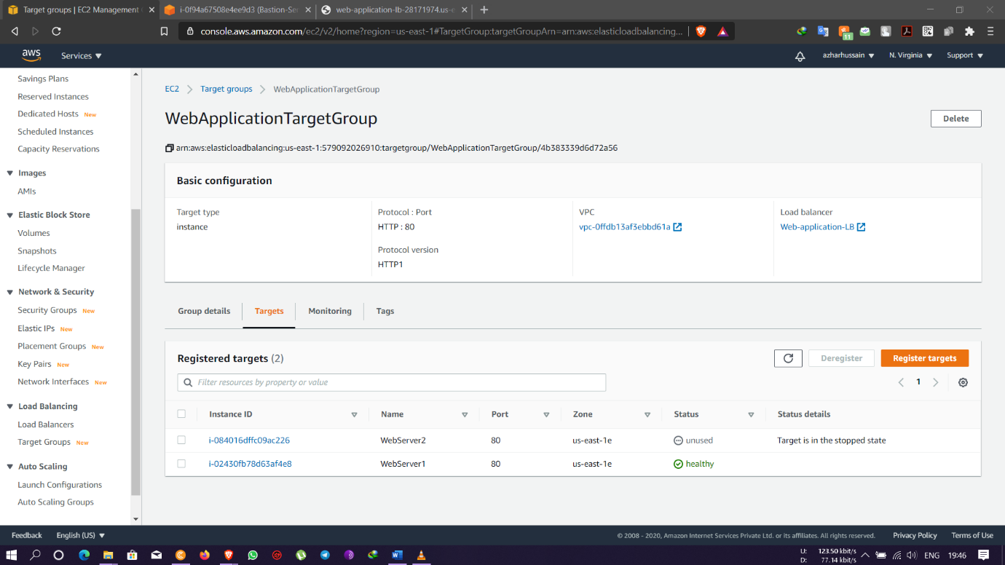



* When Web Server 2 was terminated it was found that the request was still handled by web server 1 and the same will follow for Web Server 1 when terminated

